5/31/2023

Online Cab Booking System

Batch 6 -Team 5

**Team Members:**

1.Nirmala Selvaraji -11764932

2.Johnsirani Senthilkumar -11764924

3.Kanulla Vidhya -11764963

4.Karthigashree Saravanan -11764958

5.Harinyvidhya Subbiah -11764950

6.Jayara6.Jayaraj C L -11764926

7.Govardhan Sai Naga Teja Poola -11764943

**Online Cab Booking System**

**Problem Statement:**

This Project is being considered in order to reduce and eliminate the loss of customers to competitors and save the company from folding up. The Current System is manual and it is time-consuming. It is also cost-ineffective and the average return is slow and diminishing.

Currently, customers can call or walk in to rent or reserve a vehicle. The staff of the company will check their file to see which vehicle is available for rental. The current system is error-prone and customers are dissatisfied. The goal of this project is to automate vehicle rental and reservation so that customers do not need to walk in or call in order to reserve a vehicle.

This Project aims to provide software to car booking services that maintain information about the customer details, vehicle details, driver details, booking details, and transaction details of the customer.

**Topics Used:**

**Backend:**

1. **Java:**

Java is a high-level, class-based, object-oriented programming language that is designed to have as few implementation dependencies as possible. It is a general-purpose programming language intended to let programmers write once, and run anywhere that compiled Java code can run on all platforms that support Java without the need to recompile.

1. **Spring Boot:**

Spring Boot is an open-source Java-based framework used to create a micro Service. It is developed by Pivotal Team and is used to build stand-alone and production-ready spring applications. Spring Boot provides a good platform for Java developers to develop a stand-alone and production-grade spring application that you can just run.

**Frontend:**

1. **HTML:**

The Hypertext Markup Language or HTML is the standard markup language for documents designed to be displayed in a web browser. It can be assisted by technologies such as Cascading Style Sheets (CSS) and scripting languages such as JavaScript.

1. **CSS:**

CSS is designed to enable the separation of content and presentation, including layout, colors, and fonts. This separation can improve content accessibility; provide more flexibility and control in the specification of presentation characteristics; enable multiple web pages to share formatting by specifying the relevant CSS in a separate .css file, which reduces complexity and repetition in the structural content; and enable the .css file to be cached to improve the page load speed between the pages that share the file and its formatting.

1. **Angular:**

Angular is a development platform, built on TypeScript. As a platform, Angular includes A component-based framework for building scalable web applications. A collection of well-integrated libraries that cover a wide variety of features, including routing, forms management, client-server communication, and more A suite of developer tools to help you develop, build, test, and update your code.

1. **JavaScript:**

JavaScript (js) is a light-weight object-oriented programming language which is used by several websites for scripting the webpages. It is an interpreted, full-fledged programming language that enables dynamic interactivity on websites when applied to an HTML document.

**5.DataBase – MySQL**

MySQL is a widely used relational database management system (RDBMS).MySQL is free and open-source.MySQL is ideal for both small and large applications.

**Modules in UI:**

**Registration for new User:**

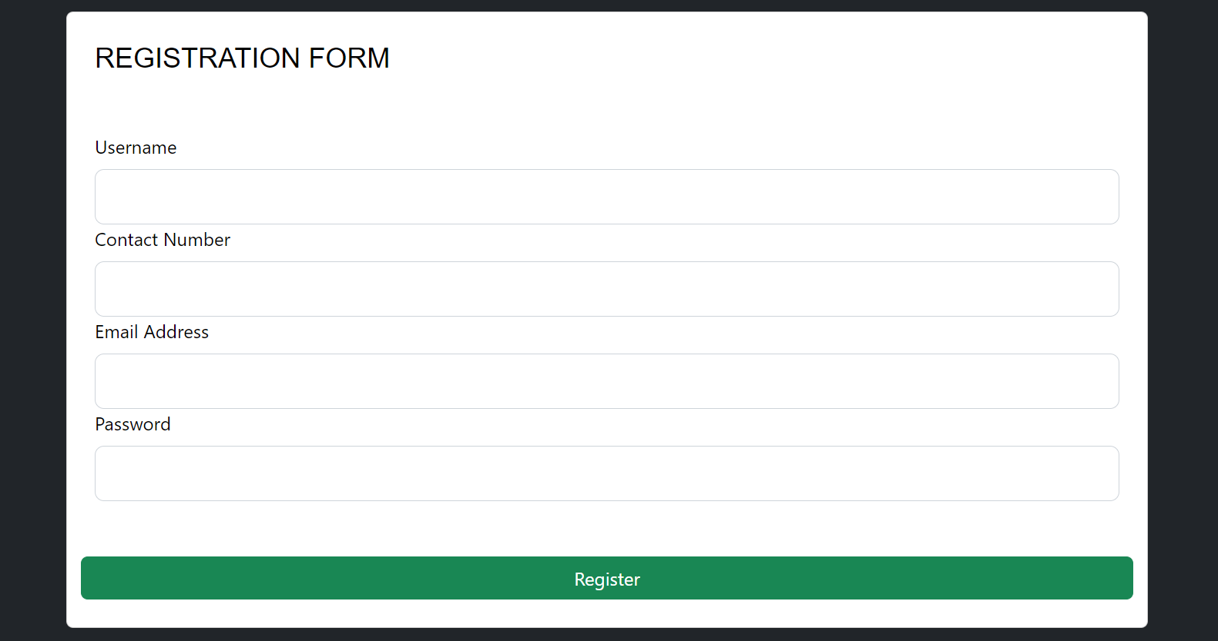

**Admin Modules:**

Admin Profile – Shows the following modules,

1. Cab Approval
2. Add Driver
3. Driver List
4. Booking List
5. Customer List
6. Car

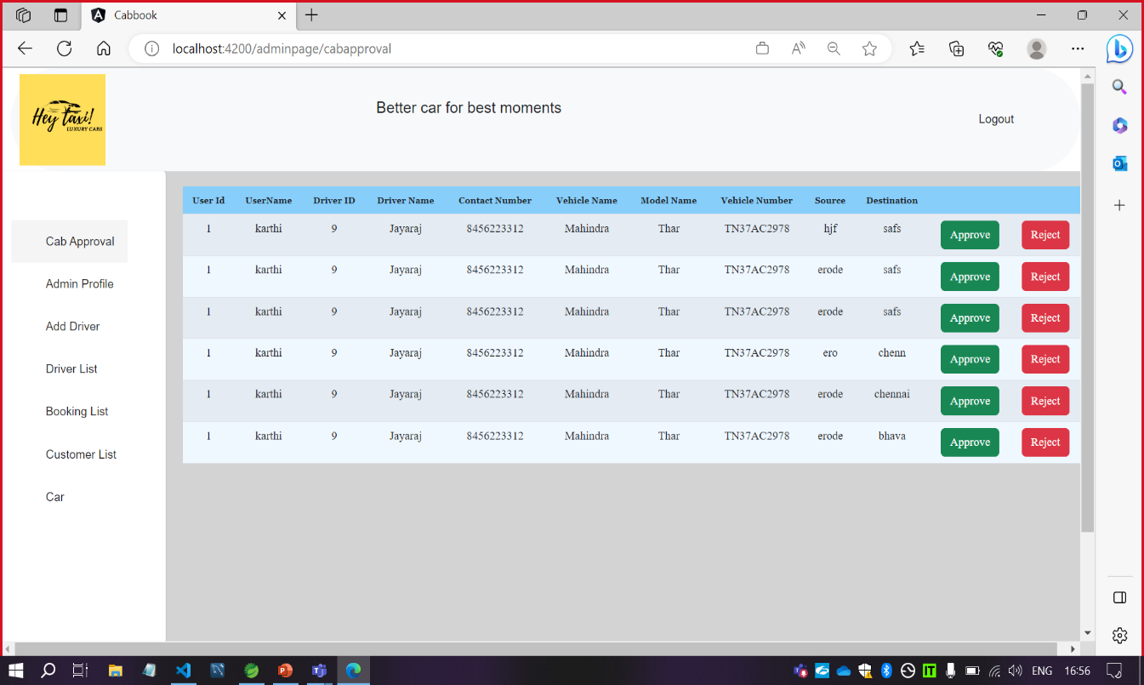

**NEW DRIVER REGISTRATION:**

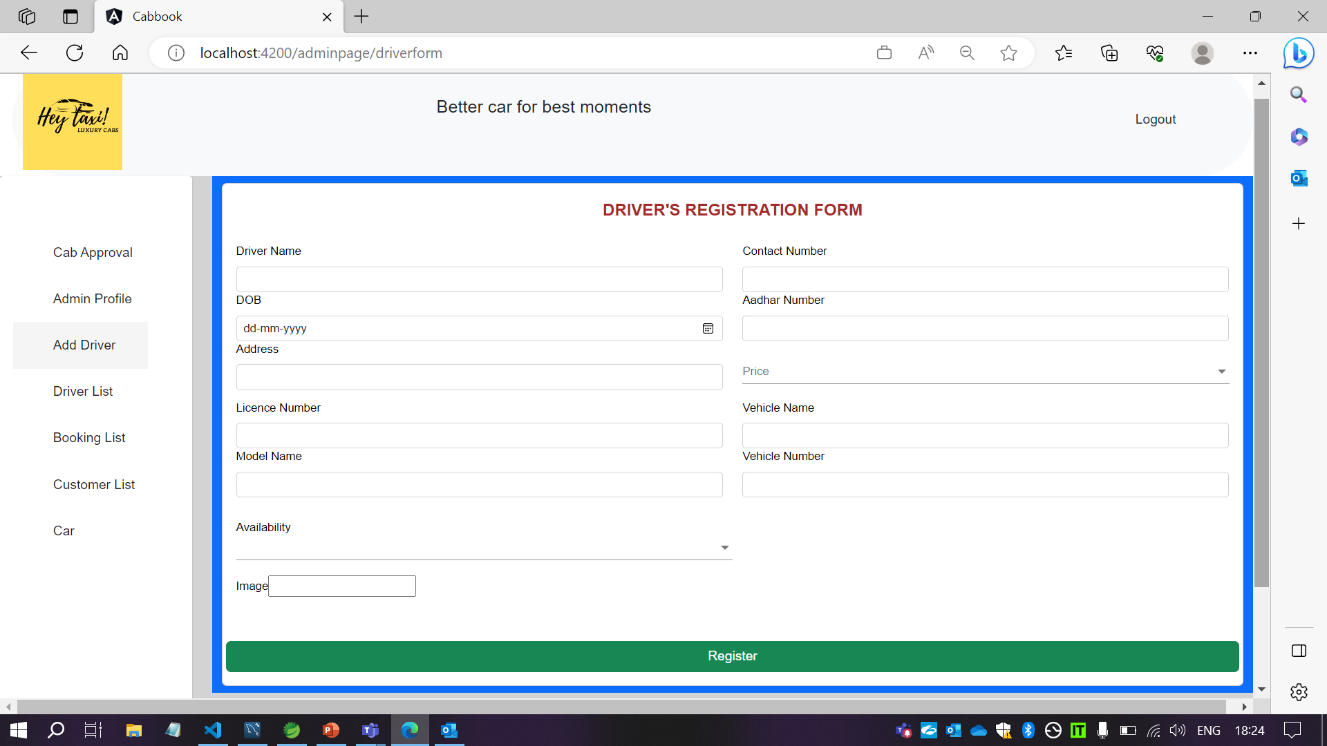

**Customer Modules:**

1. Car
2. My Bookings
3. Customer Profile

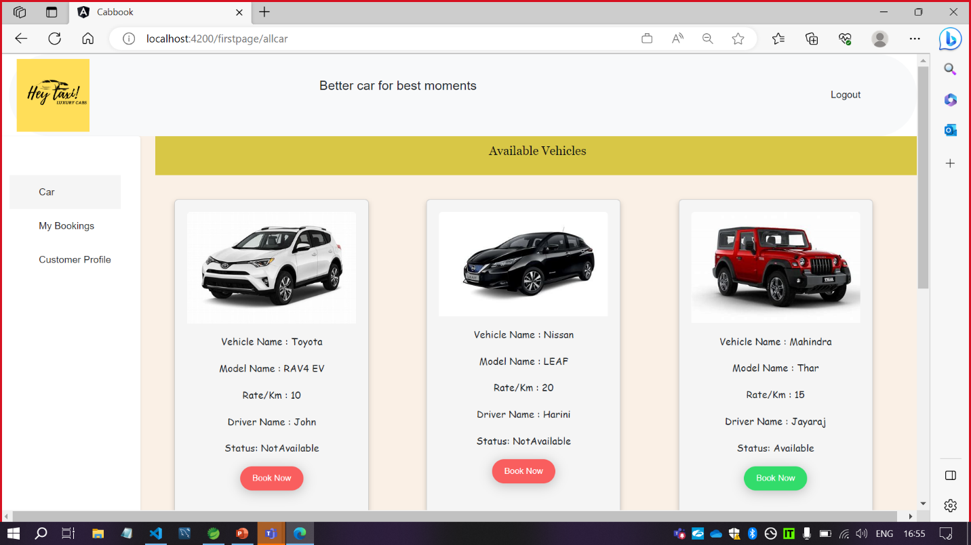

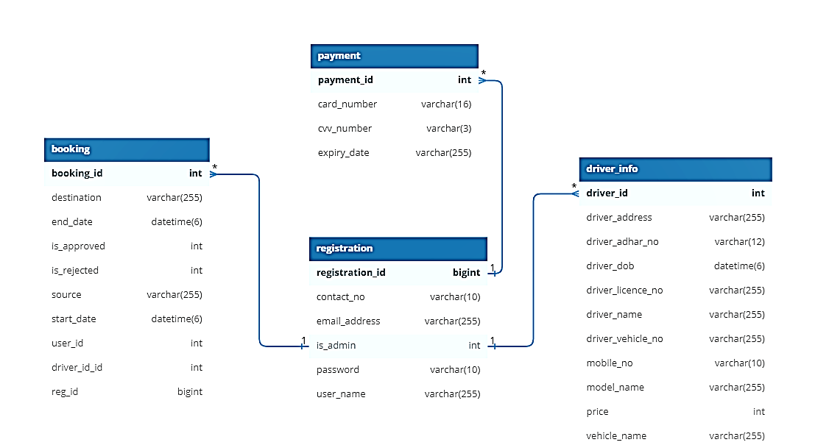**ER Diagram:**

**Use-Case Diagram:**

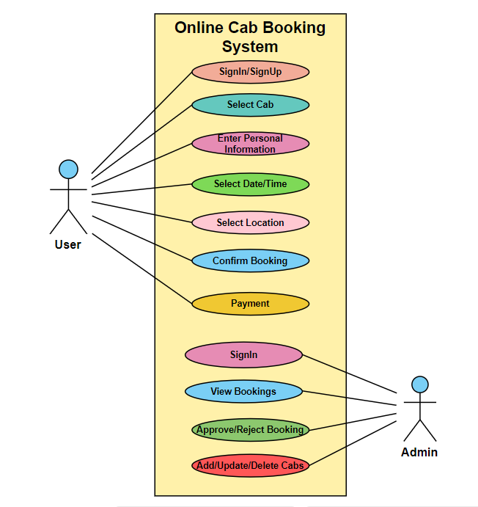

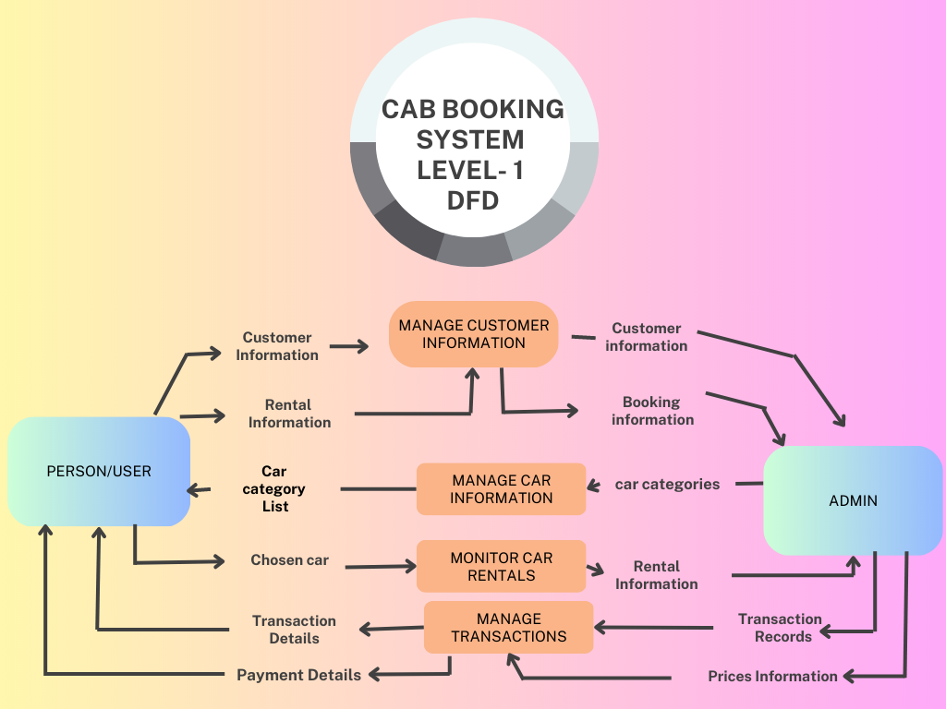**DFD Diagram:**

**Components used in Front End – Angular JS**

**1. App Folder :**

***Sub – Folders:***

* About
* Adminpage
* Allbooking
* Allcar
* Allcustomers
* Alldriver
* Bookingform
* Cabapproval
* Cardetails
* Customerform
* Customerprofile
* Dashboard
* Driverform
* First-component
* Firstpage
* Homepage
* Login
* Navbar
* Sidebar
* Index.html
* Style.css

**2.Assets**

**3.Environments**

**Commands to run Angular app:**

1.npm install

2.npm start / ng serve

**Backend – Spring Boot**

***Steps for creating a new project:***

1. **Creating a new project using spring starter project**

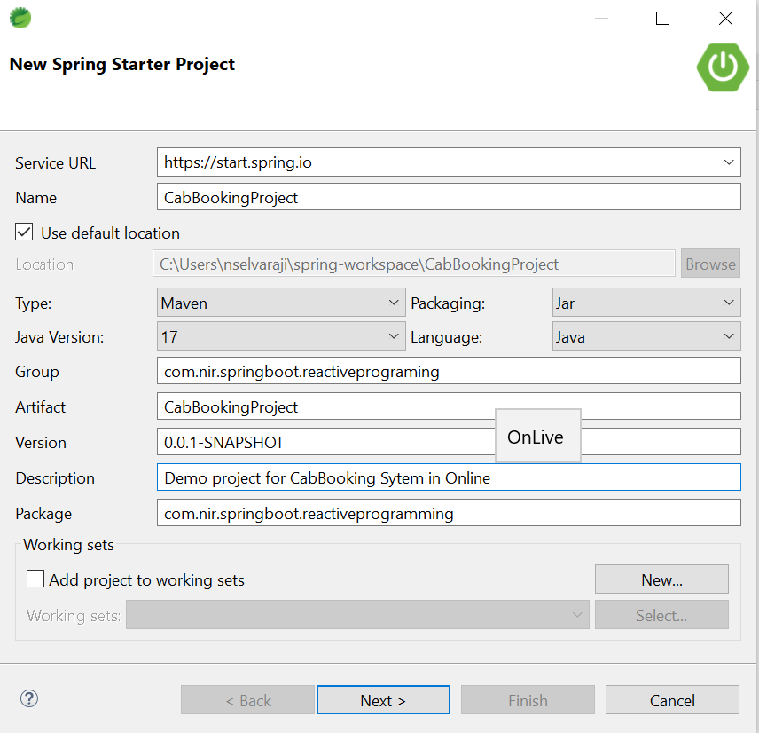

**2.Adding Dependencies:**

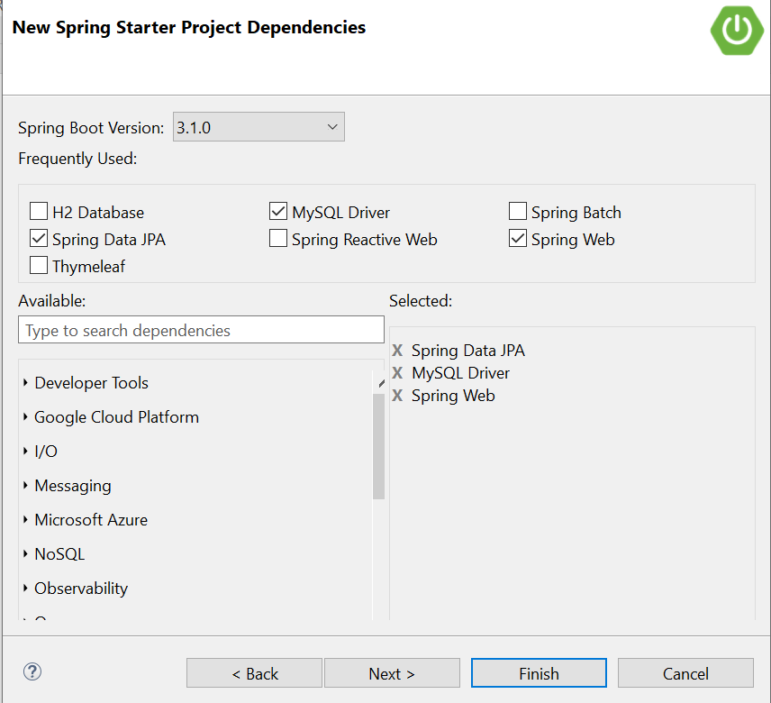

**3.Finish – Project Ready**

**MYCABBOOKING PROJECT BACKEND:**

**src/main/java**

* com.cabbook(Package)
* MyCabBookingProjectApplication.java
* com.cabbook.controller
* BookingController.java
* DriverInfo.java
* PaymentController.java
* RegistartionController.java
* com.cabbook.exception
* InvalidRequestException
* UserNotFoundException
* com.cabbook.model
* Booking.java
* DriverInfo.java
* Payment.java
* Registartion.java
* com.cabbook.repository
* BookingRepository.java
* DriverInfoRepository.java
* PaymentRepository.java
* RegistarationRepository.java
* com.cabbook.service
* BookingService.java
* BookingServiceImp.java
* DriverInfoService.java
* DriverServiceInfoImpl.java
* PaymentService.java
* PaymentServiceImpl.java
* RegistrationService.java

**src/main/resources**

* application.properties – configuration file

**src/test/java**

* **com.example.demo**

MyCabBookingProjectApplicationTests.java

**Target**

* mvnw
* mvnw.cmd
* pom.xml – dependencies

**Database: MySQL**

* Download MySQL -

[*https://www.mysql.com/downloads/*](https://www.mysql.com/downloads/)

* Command for create database

create database database name;

* Command for change database

use database name;

* Command for display table data

select * from table name;